Exhibition and Sponsorship
Booking Form

Please return to:
BSHI c/o Executive Business Support,
Unit E1, City Wharf, Davidson Road, Lichfield, Staffordshire,
WS14 9DZ
Alternatively, by email:
BSHIConference@execbs.com

Name of Organisation: ___________________________________________________________________
Contact name (s):_______________________________________________________________________
Position: ______________________________________________________________________________
Address:______________________________________________________________________________
_____________________________________________________________________________________
Postcode:___________________________________
Contact Tel: ________________________________ Mobile:____________________________________
Email: _______________________________________________________________________________
Signed: __________________________________________ Date: __________________________________

Sponsorship
I am interested in sponsoring the BSHI 2018 Conference as follows:
Item | Amount £ | Total
Keynote Speaker – Europe | 600
Keynote Speaker – UK (x6) | 250
Gala Dinner – 3 Course Meal | 3500
Gala Dinner- Dinner Refreshments | 1500
Gala Dinner- Entertainment | 750
Gala Dinner- Pre-dinner Refreshments | 600
Gala Dinner- Table Gifts | 300
Delegate Bags | 1000
Delegate Lanyards | 300
Pens inside delegate bags | 300
Notepads inside bags | 300
Advertising literature inside bags | 250
Delivering a 20 minute lunchtime workshop  (4 sessions available) | 500
Poster Session Sponsorship | 1000

Depending on the amount pledged, sponsorship benefits will include:
- Logo and acknowledgement in conference literature
- Logo and listing on conference website
- Logo and acknowledgement on selected introduction and closing slides
- 200 word corporate profile in conference handbook
- Copy of full delegate list
- Complimentary places at the conference

Advertising in Conference Handbook
€ A5 colour outside back cover - £350 | € A5 colour inside back cover – £225 | € A5 black and white within handbook - £175
 |  |  | Total: £

Exhibitor Stand Booking Form
Stand information
All exhibition spaces are approximately 2m x 2m. 1 x 500w socket is included.
Single Stand Exhibitor Package £1300
2m x 2m exhibition space
Lunch and refreshments for 2 exhibition stand personnel during exhibition
Company profile in the conference handbook and the BSHI conference website
Double Stand Exhibitor Package £2400
4m x 2m exhibition space
Lunch and refreshments for 4 exhibition stand personnel during exhibition
Company profile in the conference handbook and the BSHI conference website
To reserve your stand, please refer to the floor plan on the next page and complete the table below:
Note: We will try to allocate your preferred stand, but this may not be possible
Item | Price | Number Required | Total | Preferred Stand Choices
Single 2m x 2m Exhibition Stand | £1300
Double 4m x 2m  Exhibition Stand | £2400
Additional Stand Personnel for Exhibition duration | £200
“Sponsorship of the Exhibitor Bingo” | Prize to be donated
 |  | TOTAL: | £

Please provide a brief description of your exhibition display, including any equipment to be displayed. ________________________________________________________________________________________________________________________________________________________________________________________________________________________________________________________________________________________________________________________________________________________________________________________________________________________________________________________________________________________________________________________________________________________________________________________________________________________________________________________________________________________________________________________________________________________________________________________
Please note: BSHI will not accept cancellation or withdrawal of any application once it has been made. The full cost of the exhibition sponsorship will be payable irrespective of non-attendance. BSHI reserve the right to alter the layout of the stand plan and to transfer a company to an appropriate alternative site. Stands cannot be reserved without payment.
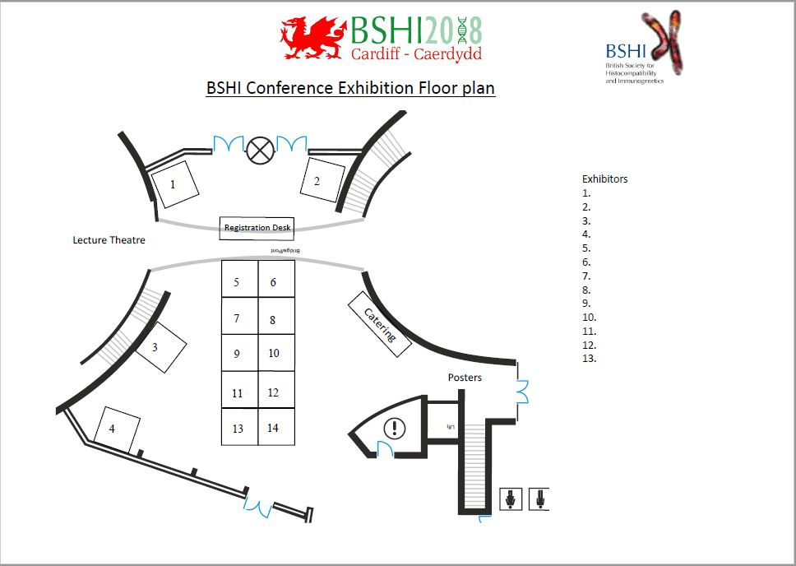
Conference Dinner Tickets
Number of tickets required | Dietary Requirements | Cost per person - £65.00
Example: 5 | 2 vegetarian | £325
Do you wish to book accommodation?
Accommodation will be reserved on a first come first served basis. All rooms are on a bed and breakfast rate.
Cancellation of rooms after 5th June 2018 will be charged in full unless the accommodation can be resold.
Night | No. Rooms required and names | Hotel and Room Type (Please Circle)
 |  | Hilton Hotel | Jury’s Inn | Holiday Inn
Tuesday 4th September |  | £149 (single occupancy)  £159 (double occupancy) | £129 (single occupancy) | £105 (single occupancy)  £115 (double occupancy)
Wednesday 5th September |  | £149 (single occupancy)  £159 (double occupancy) | £129 (single occupancy) | £105 (single occupancy)  £115 (double occupancy)
TOTAL |  | £ | £ | £

Stand Personnel Names
Title | Name | Surname | Job Title | Days attending | Dietary Requirements | Attending Conference Dinner?
 |  |  |  | Wed / Thurs
 |  |  |  | Wed / Thurs
 |  |  |  | Wed / Thurs
 |  |  |  | Wed / Thurs
 |  |  |  | Wed / Thurs
 |  |  |  | Wed / Thurs

Address for invoicing: ________________________________________________________________________________________________________________________________________________________________________________________________________________________________________________________________________________________________________________________________
Postcode:___________________________
Purchase Order Number:_______________________________________________________________
Finance Email Address: ________________________________________________________________

Confirmation will be sent to you on receipt of your completed exhibition booking form. An exhibition pack containing details stand set up times, access, health and safety information, risk assessment form and exhibition plan will be sent to you 4 weeks before the event.

